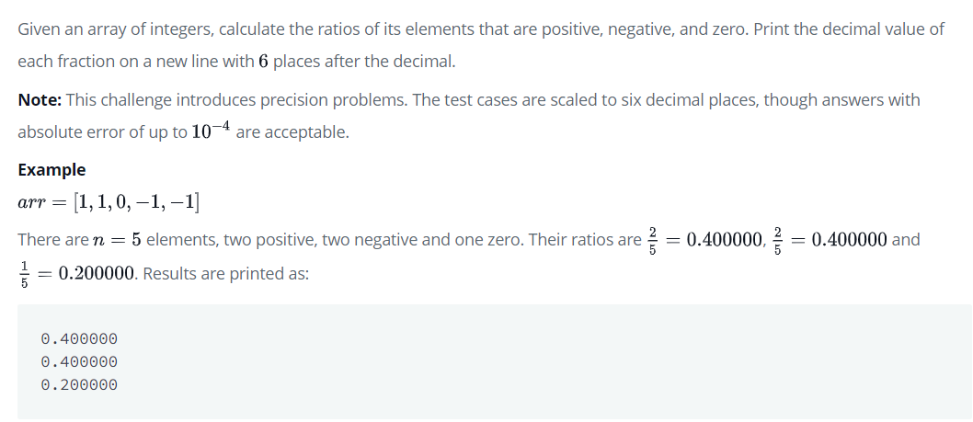

CODE:

<script>

var x=prompt("how manny elements you want to upload");

var list=[];

var positive=0;

var negative=0;

var zero=0;

for(var j=0;j<x;j++)

{

list[j]=prompt("enter the element");

if(list[j]>0)

positive++

if(list[j]==0)

zero++

if(list[j]<0)

negative++

}

var positiveratio=(positive/x);

document.write("positve no's ratios" + positiveratio.toFixed(6) + "<br>");

var negativeratio=(negative/x);

document.write("negative no's ratio " + negativeratio.toFixed(6)+ "<br>");

var zero=(zero/x);

document.write("zero no's ratio " + zero.toFixed(6)+ "<br>");

</script>